LENT 2024
Our topic this term Is,
A Ticket to Ride!

Communication & Language
We will learn lots of new language, our teachers will help us use these new words and concepts during play. We will develop our conversations skills, listening to others and responding appropriately.
We will be encouraged to make comments and ask questions about our learning. Our teachers will support us by asking questions and adding resources to our play.
We will listen to a range of books, non-fiction, fiction and poetry.
Literacy
We will continue to follow the RWI scheme, learning in smaller groups, this is how we will begin each day.
We will read every day in our phonics groups. We will bring home cards or books to practise our reading, these will match the sounds we know.
We will be learning to tell, write and adapt stories following the Talk for Writing program. Our first story is ‘Whatever Next!’.

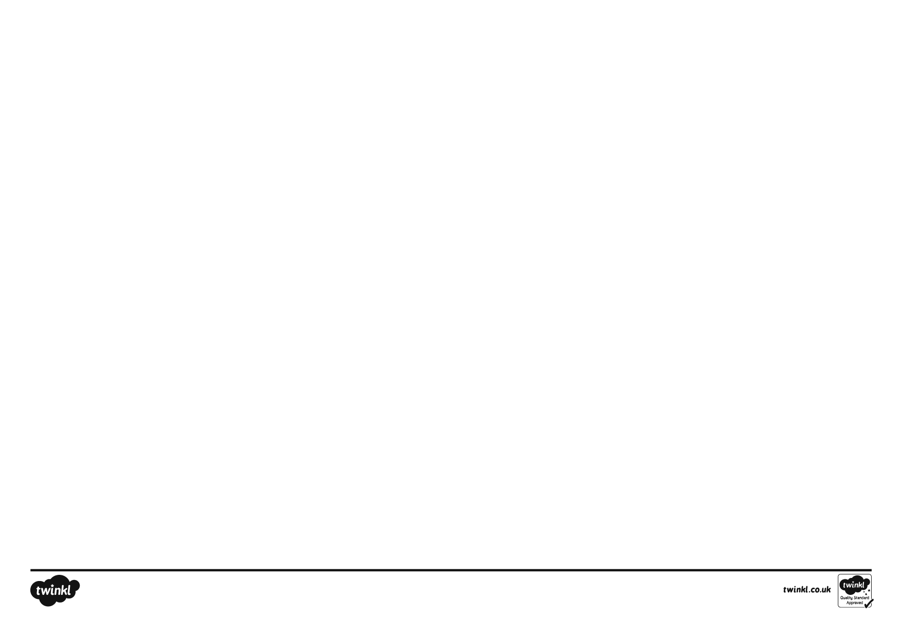

Mathematics
We will be following the White Rose Maths scheme.
Number: We will be working with numbers 0-10. We will compare numbers, order numbers, look at how those numbers are composed eg, finding two or three numbers that together make 6. We will look at one more, one less and count objects from a larger group. We will make pairs building on our work from the autumn term. We will group objects into pairs, noticing that sometimes there may be an odd one left over.
Measure, Shape:and Spatial Thinking:
We will build on our understanding of capacity to show nearly full, nearly empty, half full. We will explore this with water, sand, rice and other materials. We will make direct comparisons holding objects to estimate which feels heaviest. We will learn about 3d shapes and create and recognise patterns.

Personal, Social & Emotional Development

We will discuss our feelings and widen our vocabulary to enable us to say how we are feeling. We will think of positive things to say about ourselves and others
We will build our independent skills in relation to toileting, changing shoes and putting on our waterproofs and aprons.
We will continue to build our friendships, helping our friends and including other people’s ideas into our play. Our conversation skills will help us with this.
We will learn about how we keep ourselves healthy, with a focus on looking after our teeth. We will learn how to brush our teeth and which food and drinks are good for keeping our teeth healthy.
Understanding of the World
We will look at simple maps of our school and follow the maps to see what we notice and discover.
We will look at transport in the past, present and future.
We will continue to learn about the seasons and describe changes as we notice them.
We will take part in the rspb wild challenge, learning about nature and how to take care of creatures in our environment. We will take part in the Big Schools Bird Watch.
We will learn about different celebrations, Chinese New Year, Pancake Day, Lent and Easter.
Expressive Arts & Design
We will continue to join in with music lessons with our music teacher, learning new songs and actions. We will become more confident at performing in front of the class.
We will make collages with a variety of materials. We will explore different types of glue and tape. We will develop our fine motor skills exploring ways we can change materials eg cutting, tearing, folding, punching holes…
We will make use of props to tell stories.
We will make our own resources for imaginative play.

Religion:
We will learn to say our school prayers.
We will learn to sing lots of hymns.
We will listen and participate in Celebration of the Word.
We will learn that the Wise Men took gifts to Jesus. We will listen to different versions of the story and learn that God loves everyone across the world.
We will find out what happens during mass, how people gather together to celebrate and some special objects that are used.
We will learn about Lent and how we use this time to grow as people. We will plant and care for flowers and vegetables.
We will learn about the story of Easter.
Physical Development
We will develop our gross and fine motor skills through a variety of experiences.
We will be playing games, indoor and outdoor, during ‘choosing time’ and PE lessons. We will develop our fitness through circuit activities and team games.
We can move freely in our garden developing our balance, coordination, strength and agility.
We will develop our fine motor skills through playing with small toys, malleable materials, puzzles, scissors and building blocks.
We will work towards developing a good pencil grip in whichever is our dominant hand.

